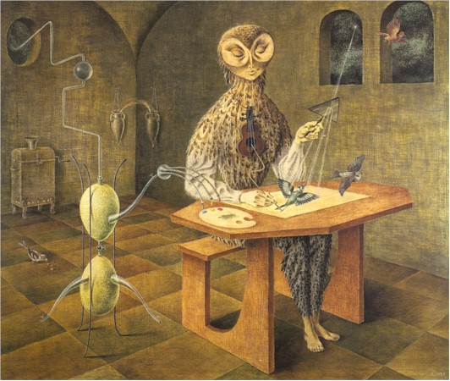

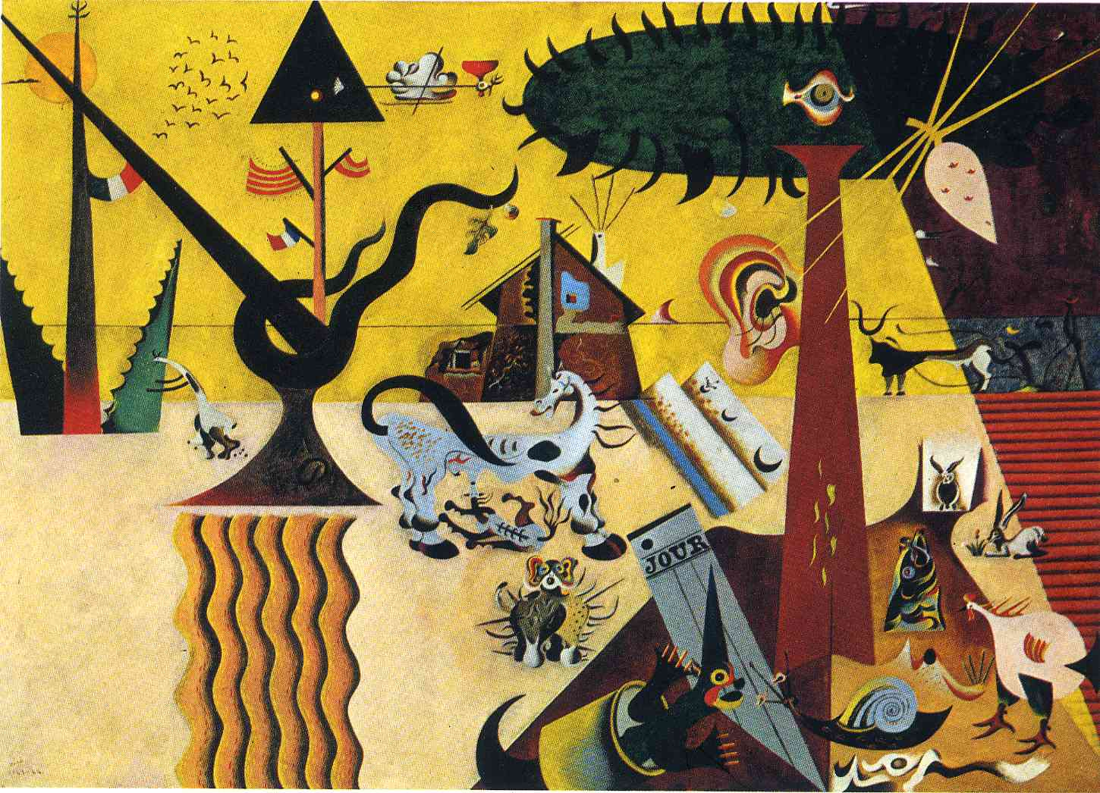

The Tilled Field (1923)
Artwork description & Analysis: Populated with complex, often inscrutable forms, The Tilled Field, with its puzzling iconography, is an abstract depiction of the landscape of Miró's Catalan homeland. The painting, teeming with organic forms that merge and meld seemingly in defiance of nature, is a testament to Miró's ever-increasing stylization and abstraction at this point in his career. The picture may be viewed as both an homage to Spain's past and a statement on the contemporary political upheaval in Europe. In works like this one, as well as works from the period leading up to and throughout World War II, Miro frequently expressed his own political sentiments. The painting also emphasizes how extremely radical Miró's departure was from his previous, naturalist style once he arrived in Paris and was exposed to the avant-garde art of that city where innovation thrived.
http://www.theartstory.org/artist-miro-joan-artworks.htm

The Tilled Field ( La terre labourée )
During the summer of 1923 Joan Miró began painting The Tilled Field, a view of his family’s farm in Montroig, Catalonia. Although thematically related to his earlier quasi-realistic, Fauvist-colored rural views, such as Prades, The Village, this painting is the first example of Miró’s Surrealist vision. Its fanciful juxtaposition of human, animal, and vegetal forms and its array of schematized creatures constitute a realm visible only to the mind’s eye, and reveal the great range of Miró’s imagination. While working on the painting he wrote, “I have managed to escape into the absolute of nature.” The Tilled Fieldis thus a poetic metaphor that expresses Miró’s idyllic conception of his homeland, where, he said, he could not “conceive of the wrongdoings of mankind.”
The complex iconography of The Tilled Field has myriad sources, and attests to Miró’s long-standing interest in his artistic heritage. The muted, contrasting tones of the painting recall the colors of Catalan Romanesque frescoes, while the overt flatness of the painting—space is suggested by three horizontal bands indicating sky, sea, and earth—and the decorative scattering of multicolored animals throughout were most likely inspired by medieval Spanish tapestries. These lively creatures are themselves derived from Catalan ceramics, which Miró collected and kept in his studio. The stylized figure with a plow has its source in the prehistoric cave paintings of Altamira, which Miró knew well. Even the enormous eye peering through the foliage of the pine tree, and the eye-covered pine cone beneath it, can be traced to examples of early Christian art, in which the wings of angels were bedecked with many tiny eyes. Miró found something alive and magical in all things: the gigantic ear affixed to the trunk of the tree, for example, reflects his belief that every object contains a living soul.
Miró’s spirited depiction of The Tilled Field also has political content. The three flags—French, Catalan, and Spanish—refer to Catalonia’s attempts to secede from the central Spanish government. Primo de Rivera, who assumed Spain’s dictatorship in 1923, instituted strict measures, such as banning the Catalan language and flag, to repress Catalan separatism. By depicting the Catalan and French flags together, across the border post from the Spanish flag, Miró announced his allegiance to the Catalan cause.

https://www.guggenheim.org/artwork/2934

The Tilled Field (French: La terre labourée; Catalan: Terra llaurada) is a 1923-4 oil-on-canvas painting by Catalan painter Joan Miró, depicting a stylised view of his family's farm at Mont-roig del Camp in Catalonia. The painting shows development from Miró's earlier works, such as The Farm, and is considered to be one of his first Surrealist works, created around the same time as the more abstracted Catalan Landscape (The Hunter).
The painting measures 66 by 92.7 centimetres (26.0 in × 36.5 in). It is dominated by muted tones of yellow and brown. The image is divided into three areas by two horizontal lines, perhaps representing the sky, sea and earth; a diagonal line seems to put the top right corner of the painting in the dark of night, while the rest is in the light of day. The painting is littered with a confused mixture of forms, many with aspects of humans, animals, and plants. The various animal forms are derived from Catalan ceramics, including a lizard wearing a conical hat. A tree to the right of centre has a large eye in its green crown and a human ear on its brown trunk. Hanging from the tree is a shape covered with more eyes, possibly a pinecone, or perhaps a leaf or a spider; at the base of the tree is a folded newspaper with the French word jour (day). Further right, in the background, is a human figure following a cattle-drawn plough, based on the Altamira cave paintings. Also in the background, towards the centre, is a ramshackle house with chimney, and further left a tree-like object bearing the flags of France, Spain and Catalonia. Another plant-like object to the left bears a further flag, possibly French, perhaps symbolising the border between France (left) and Spain (right)
It is held by the Solomon R. Guggenheim Museum in New York.
https://en.wikipedia.org/wiki/The_Tilled_Field

The title of this Remedios Varo 1957 painting is Creation of The Birds. However, it says all sorts of things to me about writers and writing.
In some important sense, writers must be night owls. And, successful written creations take wings—they fly—just like all these birds that are fluttering off the pen of the Owl Artist. True, documents about the function of prestressed concrete in interstate highways may not be able to get off the ground . . .
Notice the three primary sources of the Owl Artist's work. One source is the heavens, whose emanations she nonchalantly refracts through some sort of prism in her left hand right onto the document she is writing. Another is her heart, which here is a violin hooked up directly to the hand she uses to write with (and properly so). The third is something internal—from the building itself, the structure, the environment, the physical world in which she finds herself. I may be on the wrong track here: the vista outside that portal on the left side of the room may also be the heavens also. Then again, it may be a mountain or hill side—nature itself! Notice how the emanations from these more worldly sources are distilled through an apparatus that looks for all the world like a comical moonshine distillery. Well, that makes sense too when it comes to the creation of birds or—for that matter—verbal art. Still more, the worldly distilling device oozes red, yellow, and blue colors onto the Owl Artist's palette, very much like the tubes of colors painters use. The distilling device makes me think of the aestheticians who talk about how artists transform reality to present it in their media. The distilling device makes me think of R2D2, some bizarre mechanism that we cannot understand but rely on nonetheless—a mechanism that is frankly amusing if not downright funny. Even so, it's these resources and perhaps those from the heavens as well that give us inklings of the structure and organization of the verbal works that we try to produce. That's the effort of this website: to explore those inklings.
If I'm not mistaken, the Owl Artist's eyes are closed: she's either asleep or in some sort of trance, receiving those emanations from nature and from the heavens.
Beyond this, I am joyfully baffled by this wonderful work of art. My weak imagination cannot grasp what may be going on with the mutually filling vases on the wall behind the Owl Artist; nor can I imagine what the funny little chest with the horn-like funnel is about, sitting back there against the wall. That chest, I keep wanting to think is one of those old radiating-type heaters. But that's a stretch. And of course, everything I've expressed to this point may be a stretch.
I think I need to make a pilgrimage to this painting . . .
https://www.prismnet.com/~tcm/structure/guides/painting_comments.html

Born in Spain in 1908, Remedios Varo (full name: María de los Remedios Varo Uranga) spent her early childhood traveling around Spain and North Africa, living wherever her father, a hydraulic engineer, found work. Her family finally settled in Madrid, and while there, she studied painting at the Academia de San Fernando. She left Spain for Paris in the early 1930s to immerse herself in Surrealism, but returned to Spain in 1935 to live in Barcelona and joined the art group Logicophobiste. Varo returned to Paris in 1937 to escape the Spanish Civil War (1936-1939), and in 1941, she was forced again to relocate, this time to Mexico to escape the Nazi occupation of France. She lived in Latin America for the rest of her life, becoming friends with fellow artists Frida Kahlo, Diego Rivera and others, especially fellow ex-pat Leonora Carrington. Varo’s beautifully haunting style matured throughout the 1950s and reached its height in the early 1960s. She died in 1963 of a heart attack. Despite having a well-developed, distinct style, Varo is not well known. Male Surrealists (and others in the art community) often considered the work of their female colleagues to be inferior, making it difficult for female artists to promote their work, and so many Surrealist and similarly aligned female artists like Varo suffered in obscurity. Only recently has an interest in their work begun to develop.
Varo’s paintings are highly allegorical with a wide range of influences, including pre-Columbian art, Surrealism, Sufism and the I-Ching as well as the theories of analyst Carl Jung, medieval German theologian Meister Eckhart and Russian theosophist Helena Blavatsky. Varo viewed all of these sources as avenues to self-realization and the transformation of consciousness. Her paintings portray fantastic, often female or ambiguously feminine characters in isolated, confined environments, usually in some act of creation, as in Creation of the Birds (1957). Much of her work is interpreted as an expression of her frustration at being marginalized as a woman and as a female artist — themes that are certainly expressed in paintings like Visit to the Plastic Surgeon (1960) and Woman Leaving the Psychoanalyst (1961).
But what interests me most about Varo’s paintings are not their social or political statements, but her emphasis on the mysteries and potential of the mind, especially as it finds expression in the arts. The creation of art is rendered as a kind of magic in her paintings, depicted as both a mechanical and supremely natural process. It is a way to both act on the external world and transform and nourish the self. It is a kind of alchemy, taking base materials (for Varo, masonite, oils, brushes, colors and shapes; or for me, leaves of paper and a pen, a laptop and combinations of letters that essentially mean nothing except whatever meaning we give them) and manipulating those elements to create something new and meaningful, to express the ineffable.
I discovered Varo’s work not too long ago (around the same time that the difficulties I mentioned above arose, or maybe a little before) and, in turning inward, I’ve been considering the same kinds of things that Varo depicts in her work. Many people are suspicious of fantasy, but it’s such a necessary tool for exploring ourselves, the world around us and the connections between the two.
Below are several examples of Remedios Varo’s work; click on the images to view them larger. For more information about Remedios Varo and her paintings, here’s a helpful link. And, as always, you’re welcome to leave comments at the bottom of the page.
https://somethinglooseknit.wordpress.com/2011/12/14/the-magic-of-creation-remedios-varo/

Two of Varo's paintings which depict alchemical imagery are Useless Science or the Alchemist, 1955 (Figure 1) and the Creation of the Birds, 1958 (Figure 2). Here, Varo seems to be a bird, an owl, as she sits at the table wearing a musical instrument around her neck--a three-stringed instrument, perhaps a lyre which, in ancient Greece, symbolized the human being. The alchemical vessels, which function in the realm of machines of fantasy and machines of transformative voyages, sit on the floor and look equally human, reinforcing their role as extensions or even surrogates for the human and serving to unite the artist and vessels who appear to be sharing in the act of creation. Creating birds, as the title claims, but given the artist's quest for a sense of self, perhaps it is the birds which are really creating the artist or through an alchemical process, one is being transformed into the other. Alchemy is a secret science; all that is ever shared is that it seeks to transform one substance into another, into a cosmic elixir. But in the Creation of the Birds, Varo appears to be, perhaps, the alchemist, and whereas she calls alchemy a useless science in one image, here the alchemist is literally an artist. The artist as artist is also the image she gives us in Solar Music, 1955 (Figure 3), a painting in which she becomes a musician who plays upon the rays of the sun, thereby freeing birds in the trees. Although this artist seems to be more attuned to the cosmos, the creative act is a lesser one than the act of the alchemist, at least in a visual sense. Music, however, has been associated with the heavens and the cosmos, the music of the spheres, so in that sense, the solar musician may be the more potent artist. The difference may lie, however, in that the nature of the creative quest is not the same--in one she is depicting the idea of creativity, while in the other, at issue is the quest for finding a female identity as creator.

http://www.radford.edu/rbarris/art428/Women%20of%20Surrealism.pdf

https://en.wikipedia.org/w/index.php?title=Presencia_de_Am%C3%A9rica_Latina&printable=yes

